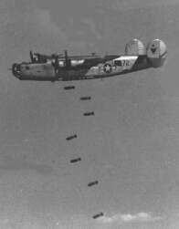
307th Reunion News Letter

March 2011 WWW.307BG.NET
_________________________________________________
Notes from the Groups President
Hi Teri;
Hi Tracy:
I hope all of you who were able to attend the incredible reunion In Branson Missouri have as fond memories of the experience as I do. It was a perfect venue for our group, the Saturday night entertainment was amazing and heartfelt, but most importantly it seemed that those children who came who have made the choice to step up and make important contributions to the sustainability of the Association are really what made it an amazing experience for me. originally it was going to be that after one month’s time I would write a letter of resignation to the Association which would then allow Jim Walsh, immediate past president, to pick the duties back up and take us all for word. Maybe I just wanted an opportunity to be able to address you all in the newsletter?
When Kathy Daniel sent the e-mail requesting that I write something for the newsletter she included news about Jack Snead’s death. This is the cycle of life, and I want you all to know that I share with you the emotional realities of end-of-life issues. At the Branson reunion we discussed and approved having reunions every year as a way of honoring our veterans more often while they still have a chance to attend reunions. The next reunion is slated for early October 2011 in Michigan. I hope with all my heart that those of you who have enjoyed the reunion in the past can find it in your budget and in your time bandwidth to think about joining us all in Michigan for a reunion.
To my delight there were many children whose fathers were regular members of the 307th Bomb Group that came to Branson. It was reported that it was worth the trip and they really enjoyed themselves. On another note, Jim Walsh and I have been working to make every effort to get the website that was once operated by Pat Ranfranz back into the operating hands of the 307th Bomb Group. Pat appears to be not cooperating in the transition and we are hoping that it doesn’t come to having to take legal action. When Jim Kendall was our historians he collected an incredible amount of valuable narrative material. As an association we owe it to the original owners of this material to ensure that it is placed in the proper and fitting place.
That’s about all I could think of to share with you at this point if any of you would like to know more about me, become friends on Face book, or communicate with me regarding the 307th Bomb Group please do not hesitate to contact me at tomayala@peak.org . In the meantime please take care of yourselves and look forward to seeing you again.
President
Tom Ayala

------ Branson Mo. Reunion Business Meeting Minutes ---------------

MINUTES BUSINESS MEETING
307TH BOMBARDMENT GROUP (HV) ASSOC.
LODGE OF THE OZARKS
BRANSON, MO
AUGUST 6, 2010 3:00 P.M.

Welcome by Jim Walsh
Business Meeting minutes from Savannah, GA reunion were read by Cathy Daniel
Motion to approve minutes as read by Sheridan Ostrander, seconded by Nancy Naegle
Motion carried.

Jim Walsh asked Milt Potee to speak about his trip to Ames, IA to honor T/Sgt. William Franklin Hodges as he was being honored by his former school. He was a member of the 307th and Milt had served with him.
Nominations for next reunion site: Hampton, VA, Nashville, TN, St. Louis, MO, Grand Rapids, MI, and Washington, DC
Much discussion about changing the time of the reunion due to the heat of the summer months. Tom Ayala and Nancy Naegle stated that the reunions used to be held in October and most members were more in favor of that.
Motion made by Nancy Naegle to close the nominations, seconded by Milt Potee
Voted for Grand Rapids, MI
Election of Officers
Nominations:
President- Tom Ayala
Vice President- Jim Walsh
Secretary- Cathy Daniel
Treasurer- Alissa Stables
Parliamentarian- Jack Palmer
Nominations were closed and all nominees were elected by a majority of the vote.
Discussion on the Historian and it was decided to appoint Jim McCabe the Historian and have all the archived materials sent to him from Pat Ranfranz
Discussion on writing campaign to members to try to get reunion attendance up. Nancy and Susan Naegle were asked to take on this task and they agreed.
Motion was made by Jim Grochowski to change the reunion from every two years to every year. Motion was seconded by Virginia Dodd. Motion carried. The next reunion will be held in October, 2011 in Grand Rapids, MI and Duane Hamsten, a new member, will be the reunion host.
The newsletter will be prepared and distributed by Cathy Daniel and Jim Walsh is working on the reunion books for the past three reunions. Darrell Hamsten, a new member, offered to help Jim with the publication of the reunion books.
Virginia Dodd and Tom Ayala wished to express THANKS to all who helped with the reunion in Branson. A good time was had by all.
Jim Walsh thanked Milt Potee for all of his help in getting the reunion together.

Motion made by Nancy Naegle to adjourn the meeting. Seconded by John Wright.
Meeting adjourned 4:11 P.M.

---- Group News with Cathy Daniel - Secretary ----
We gained five new members at the reunion in Branson, Mo.
Darrell Hampsten, Duane Hampsten, Michael Cotter, Peter Cotter, William Dodd, Jr..
Welcome gentlemen to the 307th Bombardment Group. We look forward to your participation in the group.
Branson was a very successful reunion. Everyone had a great time.
Sorry to hear from those of you that let us know you couldn’t attend the reunion because of illness. WE MISSED YOU!!!!!
Next reunion is in October, 2011 in Grand Rapids. MI. New member Duane Hampsten volunteered to be the reunion host for this reunion. Thanks Duane and if you need any help just call any of us and we will do what we can. Duane is working right now to get us all of the information about this reunion, so be expecting to hear from us in the next couple of months with all the details.
Dues are still $30.00 per year, per member. Any family member of a 307th veteran may belong to the association. Dues are always due by February 28 of each year. These funds allow us to continue to print the newsletters and mail them, mail out PX items, other correspondence, and to also help plan the reunions. Please pay your dues on time.
Send them to: Cathy Daniel, Secretary, 307th Bomb Group, 224 Kitty Hawk Bay Drive, Kill Devil Hills, NC 27948. Phone 804-399-5563. PLEASE NOTE THAT THIS IS A NEW ADDRESS FOR ME, I HAVE MOVED.
---- Historian’s Corner by Jim McCabe - Historian ----
From: Jim McCabe, Historian
307th BG Assoc.
james-mccabe@comcast.net
804-277-8014
January 2011

I was humbled and honored to accept our associations request to be the Historian for the 307th BG. In 2005 when my father, 2nd Lt. Michael J. McCabe (Gene McCullough Crew) passed away, my family and I were unaware of this association and my father, like many of you, would not talk about his service at Morotai (450220-450801). Many association members took me under their wing and helped me piece together my father’s service. My family and I are forever indebted to three association members in particular, Greg Babinski (son of S/Sgt Walter A. Babinski), Stan Batten (brother of S/Sgt. Eugene V. Batten) and Bill Helms, the BTO on my Dad’s crew for their assistance. I learned that my dad flew lead Navigator for the 424th on the following mission:

On August 1, 1945 seven crews from the 372nd and 424th flew an mission
To Makassar Town, Celebes. On the return to Morotai, the Traendly crew ditched in the ocean due to fuel loss and only some of the crew members were rescued. Stan’s brother, Radio Operator, S/Sgt. Eugene V. Batten, was not among them. For additional information:
http://www.missingaircrew.com/pdf/August71945.pdf
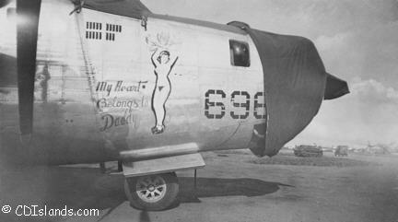

Ever since 2005, it has been a privilege to return the favor extended to me and my family. Besides assisting with research whenever I can, I’m sure you would be pleased to know that I contact any local families when I see an obituary for any Air Corps veteran and offer to provide any research desired. This is always most welcomed. On many occasions, I have attended their funerals extending our association thanks for their military service. Some highlights from this past year:
-------------------------------------------------------------------------------------------------------
March 25, 2010 4:28:23 PM
Subject: T Sgt. Joe Herzog
Stephanie,
My name is Jim McCabe and I am the VP of the 307th BG Assoc. I am trying to respond to Jesse Caparella's post re his great uncle Julio L. Caparella and I saw from your post that you know the pilot's name. Could you please provide it to me so I can research this matter? As your great uncle, Joe, also served on this crew, I will share my findings with you as well if you wish. To start, it appears from this listing at accident-report.com that the crew was actually lost in 1943.
http://www.accident-report.com/crews/1943/NAME43H.html
http://www3.gendisasters.com/nebraska/14114/wayne-ne-bomber-crashes-oct-1942
http://www.nebraskaaircrash.com/memory/wayne1.html
http://www.aviationarchaeology.com/src/namesH.htm
Thanks in advance for your assistance.
Jim McCabe
Jim,
You do not know how excited I was to hear you wanted to research my great-uncle and the crew! I am AMAZED at the links you provided me with! New information to me about the accident in 1942! Anyway, in my post in the forum, I misspoke and said 1 LT. Orlin R. Wyse was the co-pilot, but he was in fact the pilot. 1 Lt. Quentine L. Wagner was the co-pilot. My mother and I do not know who wrote the names and duties on the back of the picture she found...so crossing our fingers that the info in correct. If you need any more information on other crew members, please let me know! If you need anything at all, please feel free to contact me!!
Thank you so much again! I was able to contact Jesse Caparrella and we are keeping in touch through e-mail. Any info you provide to me I will be sure to forward to him!
-Stephanie W
------------------------------
Stephanie & Jesse,
It has been my pleasure to assist you with your search for information regarding your great uncles. My father was a replacement crew member who served in the same squadron as Sgts. Herzog and Caparrella. I have been at this for a few hours but you’re having the pilots name has now resolved the initial search. Toward the very bottom of the link below, you will find Lt. Orlin F. Wyse's name and the date of his death, 7/25/43(in military posts this will appear as 430725). I took a chance a few hours ago and started cross-referencing 1943 losses with the database of the thousands of aircraft manufactured in 1942 (an educated guess), assigned to the 307th Bombardment Group and subsequently lost and so far found 15 B-24's lost in 1943. With your having the pilot's name and my in turn being able to find this link with the date of the loss of your great uncle's pilot, I was able to most likely find your great uncle's aircraft. Though the 307th had a rough week losing 7 of these 15 bombers from 6/30/43-7/28/43, there is only the one 307th BG bomber lost on 430725:
Serial No. 42-40856
MACR (Missing Air Crew Report) #220
http://www.rootsweb.ancestry.com/~iahenry/veterans.htm
You should both order a copy of this MACR (it's free) to confirm if this in fact your great uncle's bomber. I should forewarn you that a MACR will provide all the known information about the lost aircraft and crew including photographs, testimony of surviving squadron members etc. I will continue to search as it is possible the 307th BG lost more than one bomber that date. It is also possible that your great uncles may have survived this crash, been POW's, or evaded capture and been lost on a subsequent mission. There are lots of photos on the 307thbg.org website from 1943/Guadalcanal. It would take you a while, but I think you will find photos of your great uncles if you look. You may be aware that there is currently a 10 or 11 part miniseries on HBO entitled The Pacific. Though it is about the U. S. Marines at Guadalcanal you should both know that it is this island/airbase captured by our Marines from which your great uncles flew their missions supporting the U.S. Marines, U. S. Army, U. S. Navy and our allies, especially Australia's Army. I thank you both for the supreme sacrifice given by your great uncles and request that on behalf of the 307th BG Assoc. you extend our heartfelt thanks to all extended family members of these men. I hope you both and your respective family members will consider joining us in August at our 307th BG Reunion.
Respectfully,

Jim McCabe, Vice-President
307th Bombardment Group Association
------------------------------------------------------------------------------------------------------------
Friday, September 24, 2010 1:03:16 PM
Subject: My Dad and B-24 Era
Jim,
My sister, Doreen, spoke with you today--thank you for getting in touch with her regarding my dad's (who passed away this last Sunday) WWII/B-24 days. Attached are a few pictures we have from him, and there are a few others with his crew, which he had kept in touch with. The crew met up yearly up until a few years ago. The pilot of the crew lives in Corvalis, OR, and I can provide you with his contact info if you like. He wrote his memoirs into a book and there's a lot of information in there about the crew and their life during that time.
I had bought him several books on B-24's over the years, and at one of their reunions they visited an airfield with a restored B-24 that they got to tour. Also attached is a picture from the service we had for dad last night, with his WWII memorabilia.
They never shipped out overseas--they had orders to deploy to the Pacific in 1945 but the war ended just before they were to head out. I believe his plane was a B-24J if I recall correctly, and dad had noted that the nose gun had a radar assembly instead, for night bombing I believe. I sure wish dad was still here of course, and he could have provided a lot more information to you.
Thank you again for helping us with the flag for his burial service tomorrow, and please don't hesitate to call me if there is any additional info that I can provide. My number is below, I live in California.
-Doug
If I can be of any assistance to you with research or locating a “war buddy”, please contact me.
Jim McCabe, Historian
james-mccabe@comcast.net
804-277-8014
9260 Guenevere Pl.
Mechanicsville, VA 23116-2782
--------- We proudly serve the most Awesome Members --------
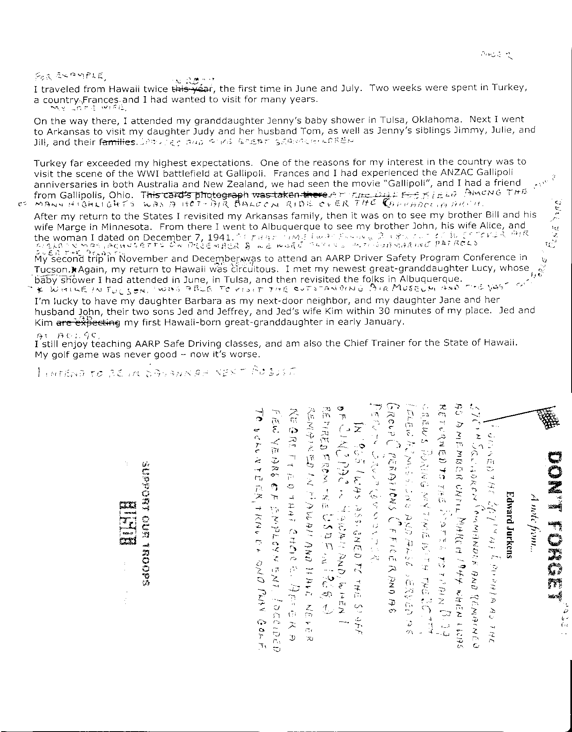
Below are the memoires’ of Col Ed Jurkens.

---- The NEWS on NOSE ART----
Then below is a conversation between Mr. John Origlio and the Vice President’s (Jim Walsh’s) sister on Nose art on the side of many of your planes out in the Pacific. See the pictures below.
From: John Origlio [mailto:joriglio@neo.rr.com]
Sent: Tuesday, January 11, 2011 8:50 PM
To: Pauline Jacobson
Subject: Re: WWII Nose Air Photographs
Pauline
Thank you so very much for the photographs. They are great pictures. The photos will be a great addition to our family history album. I can see clearly see my brothers signature in the photo of the 545. I would be very interested in making contact with anyone who may have know my brother or anything about the painting. Like, I assume Rose Marie was the pilot’s wife? From his discharge papers he was at both New Guinea and Luzon serving in the 871st Engineer Aviation Battalion.
Looking further at the other photo your dad took I think that plane 548 named Polly also looks like my brothers style but could not make out a signature.
I have a small photo of a man standing in front of the Rose Marie. I am not sure if he is ground crew or flight crew. Like all my family photographs handed down to me it is unidentified. Tomorrow I will scan it and send you a copy. Please pass it along to see if anyone in the 307th can identify who is in the photograph.
Thank you again
John Origlio
====================================================
From: John Origlio [mailto:joriglio@neo.rr.com]
Sent: Thursday, January 13, 2011 6:36 PM
To: Pauline Jacobson
Subject: Re: WWII Nose Air Photographs
Pauline
I just received a copy of the book Fighting Colors The Creation of Military Aircraft Nose Art by Gary Velasco. There is a chapter on the 307th BG filled with your father's photographs. On page 219 there is a photo of the crew of the Rose Marie. On the far left is the same person who was in the photo I sent you. It is much clearer than the photo I sent you. Of course no one is identified but he must be a member of the crew.
On that same page it also show an enlargement of your fathers photograph of XW2_442 - Indian Thumper. It clearly shows by brother’s signature. Can you please send one more photo?
Thank you
Sincerely
John Origlio
From: Pauline Jacobson
To: 'John Origlio'
Sent: Wednesday, January 12, 2011 8:26 PM
Subject: RE: WWII Nose Air Photographs
John, I am pretty sure my Dad took the photo, I will forward this to my sister, who will show it to him, and he may be able to identify the man in the photo. He is 91 years old, and his memory is going, so he may not remember. If you would like to read about my Dad and his photography, here is a link to the web pages I set up for him:
http://www.cdislands.com/ww2.htm
Pauline Jacobson
From: John Origlio [mailto:joriglio@neo.rr.com]
Sent: Monday, January 10, 2011 9:26 PM
To: pauline@cdislands.com
Subject: WWII Nose Air Photographs
Hi
I found photographs I am interested in on the web site Missingaircrew.com. They are of nose art of B-24's of the 307th Bomb Group from WWII. I have reason to believe some may be the art work of my older brother Joe Origlio who was a member of the 871st Airborne Engineers. They built and maintained the runways. My brother was a painter who stenciled insignias on the planes. On the side he painted nose air for the flight crews. I believe two of the paintings are definitely his. The first is the Rose Marie; B-24, 132. I have a small photograph of this, the only photo I have from my brother's war art. The other is the image xw2_545.jpg Unknown, this was attributed to my brother in a book on nose art "Fighting Colors: The Creation of Military Aircraft Nose Art" By Gary Velasco. He attributed the photo marked unknown to art work by my brother. In the book you can make out his signature. My brother died in 1983 and I don't have much information about his war years. Is it possible to obtain copies of these photographs?
Sincerely
John Origlio
1360 W. Arndale Road
Stow, OH 44224
joriglio@neo.rr.com
====================================================
Hello John,
The photos were taken by my Dad, James Walsh who served with the 307th Bomb Group during WWII. I have attached 2 high resolution digital files that you can make prints from. Also, I cc’d my brother, Jim Walsh who is Vice President of the 307th Bomb Group; he always appreciates getting this type of information. Please let me know if you have any problem receiving the files via email, and I will place them on a computer server for you to download.
Pauline Walsh Jacobson
http://cdislands.com
http://paulinewalshjacobson.com

Below are the artist and some of the pictures that this fine gentleman painted on the side of YOUR aircraft.
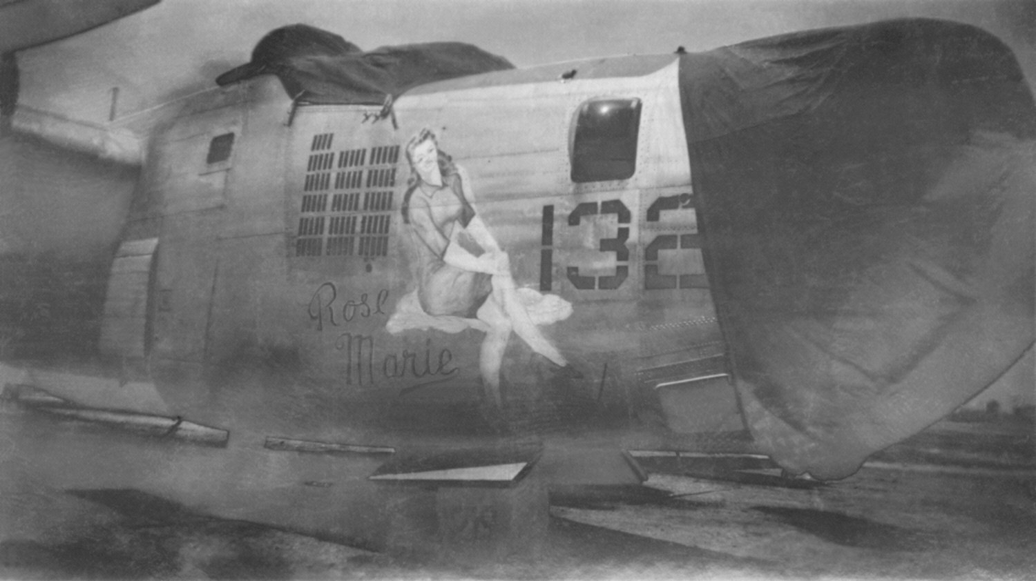
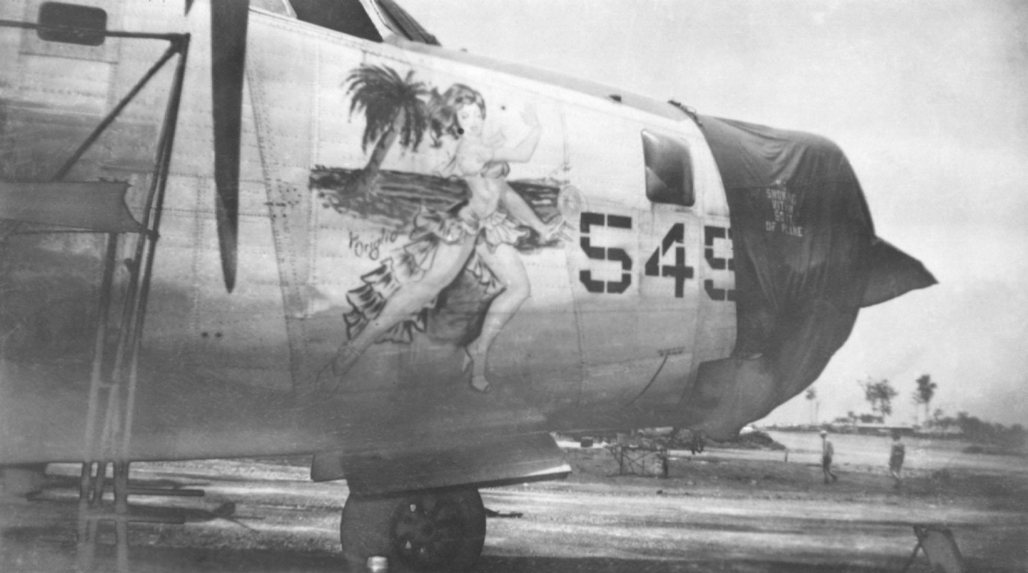
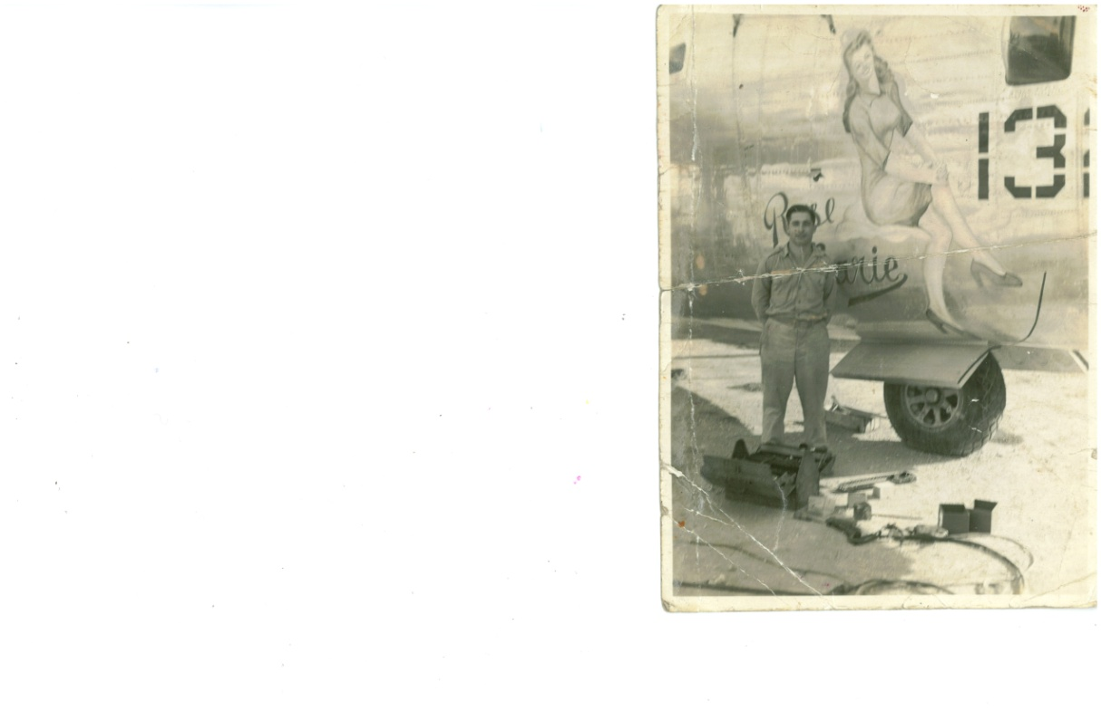
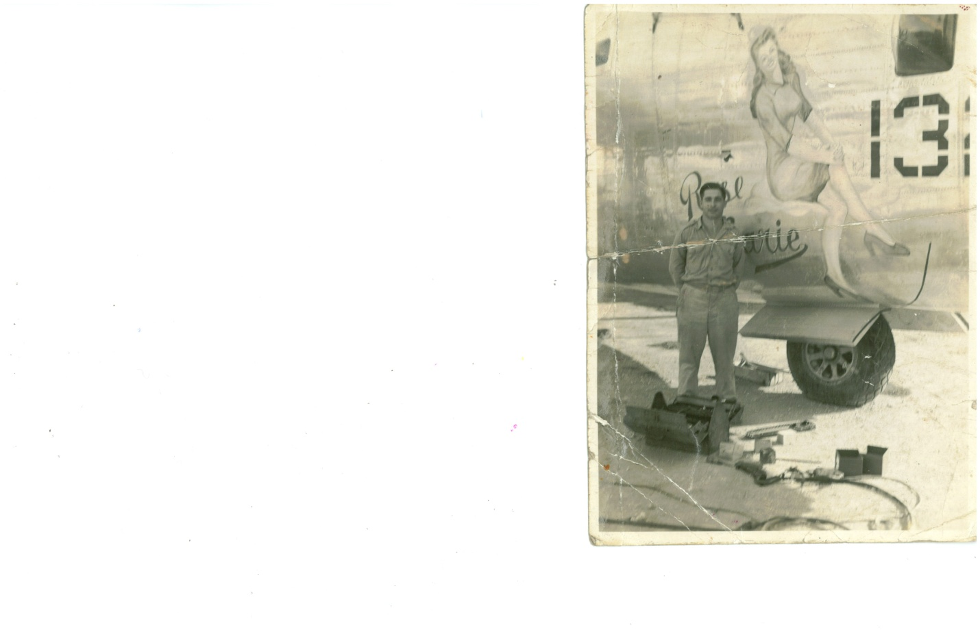
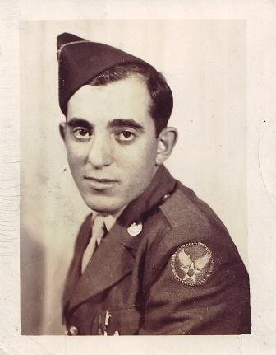

This is the Artist

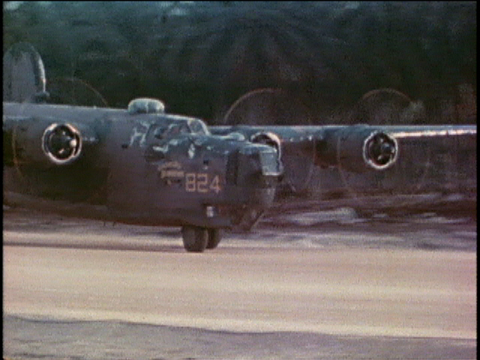

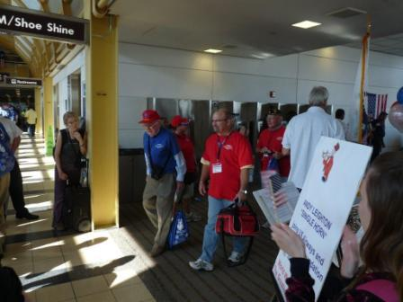
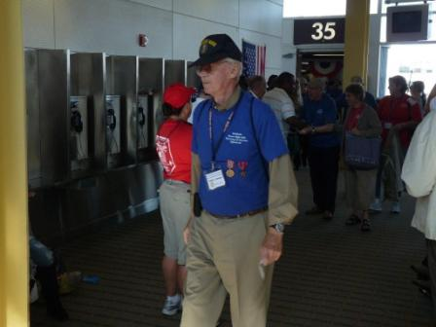
Here we have an Honor Flight returning from Washington DC where some of the 13th AF team was aboard. I cannot find who sent me these pictures however I want to thank them for taking the time to care enough to take these for our newsletter.
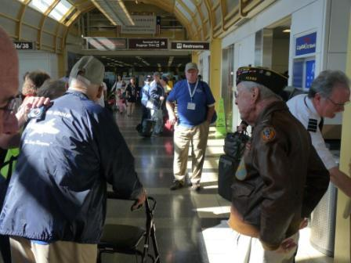
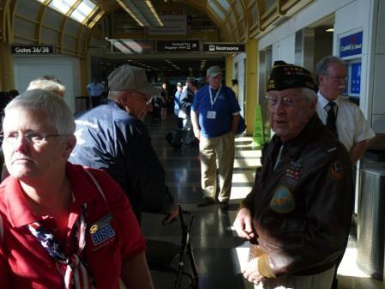

--- The 307th’s Final Flight List ----
In November, 2010 we lost Jackson B. Sneed. Jack suffered a stroked and struggled to recover. He gave it a good fight, but in the end, it was God’s will to call our friend and comrade home to be with him. We send our heartfelt sympathies to Margie, Alan, and Sandy along with the entire Sneed family. He was a Great man and friend and we will miss him greatly. Rest in Peace our Dear Friend.

